Create, Update and Remove Software in Windows

Head's up: You'll experience a delay as the labs initially load, particularly for Windows labs.

**Introduction**

In this lab, you'll learn how to install and remove software in the Windows GUI and CLI, and work with zipped files. You'll install a text editor, called Atom, and extract/un-extract .tar files. You’ll also use Chocolatey to install and uninstall programs on Windows.

**What you’ll do**

You have a bunch of tasks for this lab. First, you'll install and remove software using the Windows graphical user-interface (GUI). Second, you'll remove and install software using the Windows Command Line Interface (CLI), known as Powershell. Third, you'll extract and compress files into a .zip archive in the GUI and CLI. Last but not least, you'll use Chocolatey to manage software within the Powershell terminal.

* Install Atom using Windows GUI
* Extract files using 7-Zip and Powershell
* Install VLC using Chocolatey
* Uninstall GIMP using Chocolatey

**You will have 60 minutes to complete this lab.**

# **Software Packages and File Archives on Windows**

External IP address



content_copy

username



content_copy

password



content_copy

**Introduction**

In this lab, you'll learn how to install and remove software in the Windows GUI and CLI, and work with zipped files. You'll install a text editor, called Atom, and extract/un-extract .tar files. You'll also use *Chocolatey* to install and uninstall programs on Windows.

**Head's up**: You'll experience a delay as the labs initially load (particularly for Windows labs). So, please **wait a couple of minutes for the labs to load**. Please also make sure to access the labs **directly through Coursera** and not in the Qwiklabs catalog. If you access the labs through the Qwiklabs catalog, you will *not* receive a grade. (As you know, a passing grade is required to matriculate through the course.) The grade is calculated when the lab is complete, so be sure to hit "**End Lab**" when you're done!

You'll have 60 minutes to complete this lab.

**What you'll do**

You have a bunch of tasks for this lab. First, you'll install and remove software using the Windows graphical user-interface (GUI). Second, you'll remove and install software using the Windows Command Line Interface (CLI), known as Powershell. Third, you'll extract and compress files into a .zip archive in the GUI and CLI. Last but not least, you'll use Chocolatey to manage software within the Powershell terminal.

* Install Atom using Windows GUI
* Extract files using 7-Zip and Powershell
* Install VLC using Chocolatey
* Uninstall GIMP using Chocolatey

Start the lab

You'll need to start the lab before you can access the materials in the virtual machine OS. To do this, click the green “Start Lab” button at the top of the screen.

**Note:** For this lab you are going to access the **Windows VM** through your **local RDP Client**, and not use the **Google Console** (**Open GCP Console** button is not available for this lab).

Start Lab

After you click the “Start Lab” button, you will see all the connection details on the left-hand side of your screen. You should have a screen that looks like this:

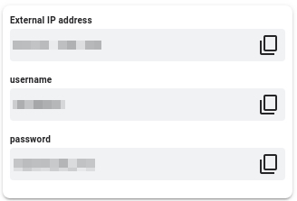

**Note:** Working with Qwiklabs may be similar to the work you'd perform as an IT Support Specialist; you'll be interfacing with a cutting-edge technology that requires multiple steps to access, and perhaps healthy doses of patience and persistence(!). You'll also be using **RDP** to enter the labs -- a critical skill in IT Support that you’ll be able to practice through the labs.

**Accessing the virtual machine**

Please find one of the four relevant options below based on your device's operating system.

Option 1: Windows Users: Connecting to your VM via RDP

In this section, you will use Remote Desktop Connection to connect to your windows instance using its external IP address.

1. Open Remote Desktop Connection by clicking the **Start** button. In the search box, type Remote Desktop Connection, and then, in the list of results, click Remote Desktop Connection.
2. Enter the external IP address of the instance you want to connect to in the **Computer** field. Find the external IP address for your instance from the Connection Details Panel on the left side. Click on **connect**.

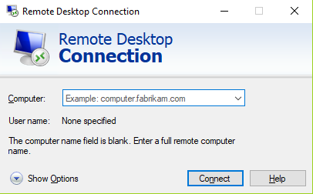

1. Change the username to **student**. And use the password mentioned in the Connection Details Panel on the left side. Click **OK**.
2. Click **Yes** to accept the certificate.

You should now see a visual interface that looks exactly like the Windows 10 OS!

If you see any error message, close the window and wait a minute or so. Sometimes the VM-creation process takes a few minutes, and you won't be able to access the VM until it's finished. This also applies to any errors that say your credentials (username and password) are incorrect.

Option 2: OS X users: Connecting to your VM via RDP

In this section, you will use Microsoft Remote Desktop 10 to connect to your windows instance using its external IP address. OSX users can [download Microsoft Remote Desktop from the Mac App Store](https://apps.apple.com/us/app/microsoft-remote-desktop-10/id1295203466?mt=12). If you are using Microsoft Remote Desktop 8, note that the interface will vary slightly than what’s listed below.

1. Open Microsoft Remote Desktop 10 application.
2. Click on **+** sign above, followed by **Add PC**.

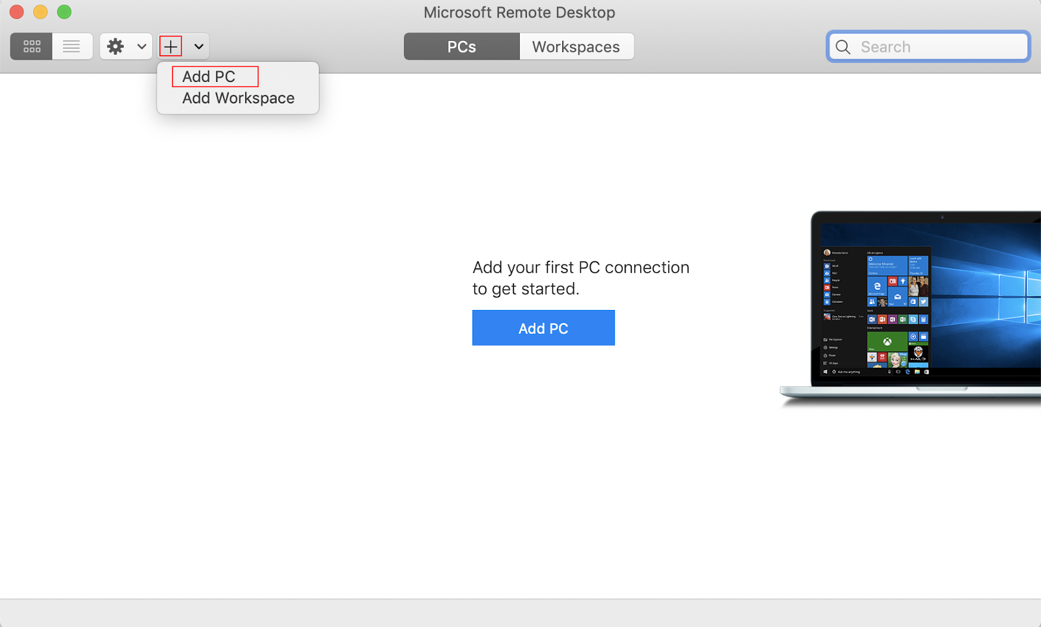

1. Enter the external IP address of the instance you want to connect to in the **PC name** field. Find the external IP address for your instance from the Connection Details Panel on the left side. Click on the **Add** button.

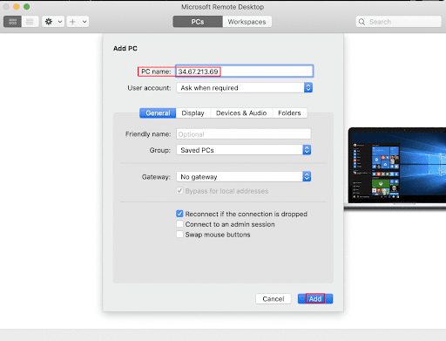

1. You should now be able to see your desktop represented by the external IP address of your VM instance under **PCs**. Double click on your VM’s external IP address.
2. The application will now prompt you for username and password. Change the username to **student**. And use the password mentioned in the Connection Details Panel on the left side. Once you have entered the details click **Continue**.
3. For any prompt regarding ‘Certificate verification’, click **continue**.

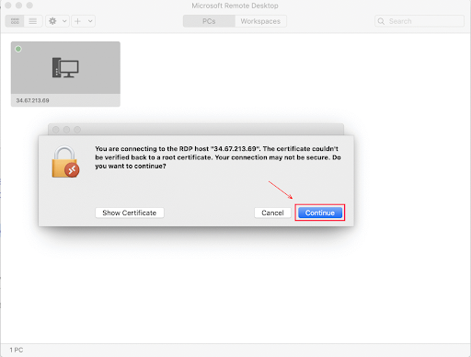

You should now see a visual interface that looks exactly like the Windows 10 OS!

If you see any error message, close the window and wait a minute or so. Sometimes the VM-creation process takes a few minutes, and you won't be able to access the VM until it's finished. This also applies to any errors that say your credentials (username and password) are incorrect.

Option 3: Chrome OS users: Connecting to your VM via RDP

In this section, you will use Chrome RDP to connect to your windows instance using its external IP address.

Chrome OS users can [download Chrome RDP from Chrome Web Store](https://chrome.google.com/webstore/detail/chrome-rdp/cbkkbcmdlboombapidmoeolnmdacpkch). Once you navigate to the download page, click on the **Add to Chrome** button. Click on **Add app** in case of any pop-ups. Then, click on **Launch app** to start the application.

1. Open the Chrome RDP application.
2. Enter the external IP address of the instance you want to connect to in the **Enter the computer name or address to connect to** field. Find the external IP address for your instance from the Connection Details Panel on the left side. Click on **connect**.
3. Leave the domain field blank. Change the username to **student**. And use the password mentioned in the Connection Details Panel on the left side. Click **OK**.
4. Click **Continue** for any window related to certificate verification.

You should now see a visual interface that looks exactly like the Windows 10 OS!

If you see any error message (an example of one is shown below), close RDP and wait a minute or so. Sometimes the VM-creation process takes a few minutes, and you won't be able to access the VM until it's finished. This also applies to any errors that say your credentials (username and password) are incorrect.

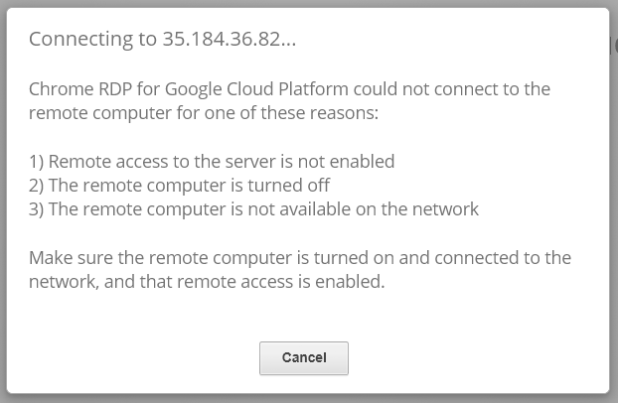

Option 4: Linux users: Connecting to your VM via RDP

In this section, you will use **Remmina** to connect to your windows instance using its external IP address. Open Remmina in your Linux machine. Linux users can [install Remmina](https://remmina.org/how-to-install-remmina/) if it is not pre-installed.

1. Open Remmina.
2. Enter the external IP address of the instance you want to connect to. Find the external IP address for your instance from the Connection Details Panel on the left side. Click on **Connect**.

Make sure the connection protocol is set to **RDP**, as shown in the image below:

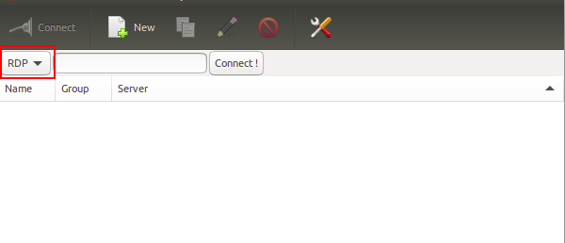

1. A window appears asking you accept the certificate, click **Ok** to continue.
2. Leave the domain field blank. Change the username to **student**. And use the password mentioned in the Connection Details Panel on the left side, for the **Password** field. Click **Ok** to continue.

You should now see a visual interface that looks exactly like the Windows 10 OS!

If you see any error message, close the window and wait a minute or so. Sometimes the VM-creation process takes a few minutes, and you won't be able to access the VM until it's finished. This also applies to any errors that say your credentials (username and password) are incorrect.

Using the Windows instance

Now you have access to the Windows instance, you're ready to start using it! This version of Windows is intended to be used on a Server, and auto-starts a server-management program. We don't need this for this lab, so wait for it to finish starting and then close it. You may see the desktop appear for a few seconds before the program launches.

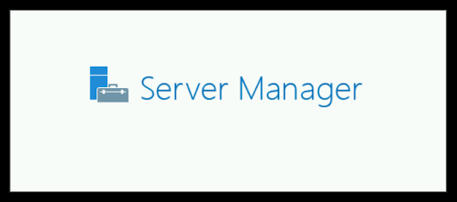 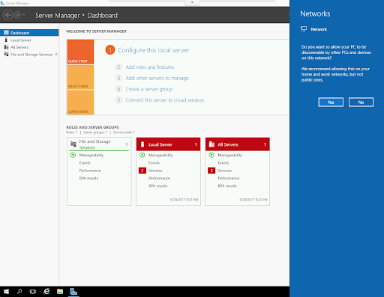

Once that's closed, the Windows OS is ready for you to use.

**Finishing the login process**

Now you‘ll see a Windows desktop background that looks like this:

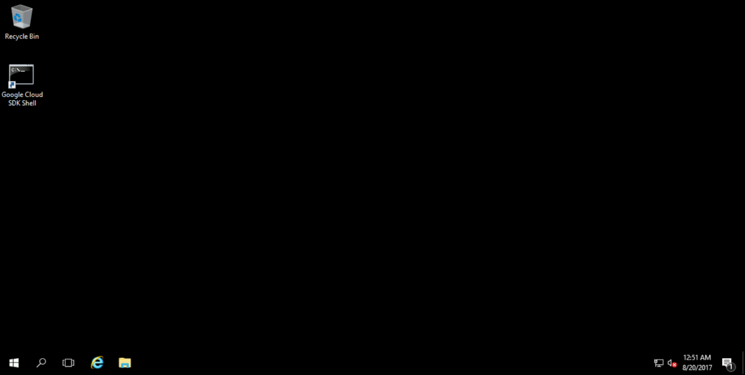

**Install and uninstall software using Windows GUI**

**Installing Atom**

First, you'll install the Atom text editor. Using Google Chrome, visit [http://www.atom.io](http://www.atom.io/) to download the latest version of Atom. Once you have downloaded the file, open your "Downloads" folder under **C:\Users\student\Downloads**. You should see the installer, called "AtomSetup-x64". Double click the executable and the process should begin:



When it's finished, Atom will automatically open:

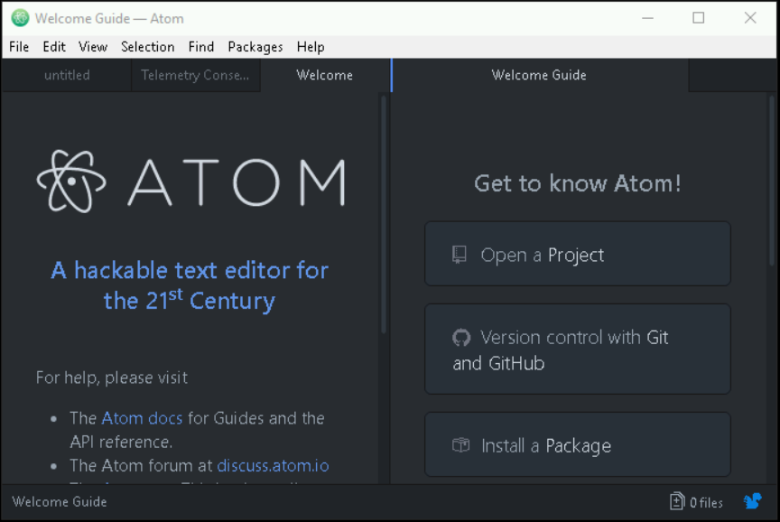

You won't need to use Atom during this lab, so feel free to close the program. Later tater!

Click Check my progress to verify the objective.

Atom

Check my progress

**Extracting using 7-Zip**

7-Zip is a super useful program for working with archived or zipped files, and it's already been installed on your system. Using File Explorer navigate to "**C:\Users\Qwiklab\Downloads**". This folder contains a .tar archive called "example.tar". You don't have permissions to extract files in this .tar file's current folder, so click-and-drag the file to the Desktop. After moving the file, you'll be prompted to confirm the move; click "Continue" to finish the move. Then, you can use it to extract the contents of the archive by right-clicking "example.tar" (now on the Desktop), hovering over "7-Zip", and clicking "Extract Here":

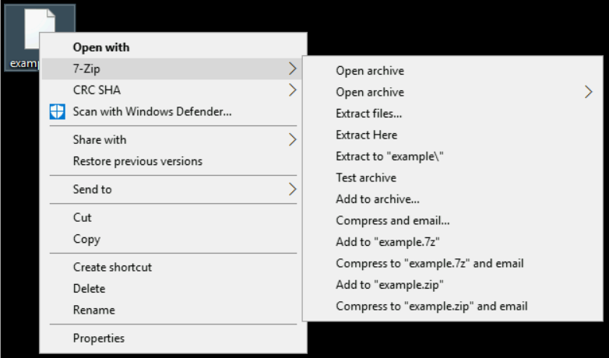

Afterwards, you'll see the contents of the .tar file on the Desktop, alongside the archive:

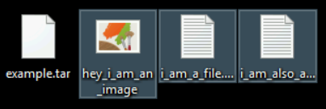

Click Check my progress to verify the objective.

Extract with 7-zip

Check my progress

**Archiving files**

Now you'll perform the other half of the process, bundling multiple files into a .zip archive. Navigate to **"C:\Users\Qwiklab\Documents"** and find the three files named, "Earth", "Mercury", and "Venus":

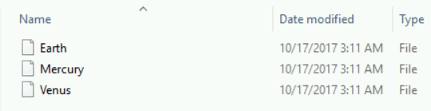

**Archiving files with Powershell**

Now you'll build multiple files into a .zip archive using Powershell. Open Powershell and navigate to this folder. (Make sure you have administrative privileges enabled!). So, search the Start Menu for Powershell, right-click it, and select **"Run as Administrator"**. Use the command

cd C:\Users\Qwiklab\Documents\

to navigate to the "Documents" folder. Once you're there, you can create a .zip archive (called Planets.zip) using this command:

Compress-Archive -Path Earth, Mercury, Venus Planets.zip

Click Check my progress to verify the objective.

Archiving Files with PowerShell

Check my progress

**Install and uninstall software using Windows CLI**

**Installing VLC**

There are alternatives to manually downloading and running installers when you need to install or manage programs on Windows. Chocolatey is a super convenient command-line tool for managing your installed applications, that can be used in the Powershell terminal. It hasn't been pre-installed on your virtual machine *windows-instance*, so you'll need to add it yourself. To install or remove programs, you need administrative privileges. So, open Powershell by searching for it in the Windows start menu, then right-click it and select "Run as Administrator".

Head's up: Some of the commands using Chocolatey print output that looks like an error message. This is usually ok, and you can proceed anyway. To avoid having this displayed, you can enter this command in your Powershell terminal:

$ErrorActionPreference= 'silentlycontinue'

**Installing Chocolatey**

In your open Powershell terminal, you first need to register the Chocolatey package with Powershell. Your machine may currently have it registered incorrectly, so unregister it with this command (if you see an error, it means that it is not registered):

Unregister-PackageSource -Name chocolatey

Then you can re-register Chocolatey, so that it can be installed using this command (one line):

Register-PackageSource -Name chocolatey -ProviderName Chocolatey -Location http://chocolatey.org/api/v2/

You'll need to enter "Y" for "Yes" when prompted to confirm the operation.

**Using Chocolatey to install VLC**

Now you can use Chocolatey to install VLC (a media player) using the following command, and bypassing the need to find and download an installer manually:

Install-Package -Name vlc -Source chocolatey

You'll be prompted to confirm the installation midway through the process. To do this, enter "A" (for "All") to accept all prompts at once.

You can verify that VLC has successfully been installed with this command:

Get-Package -Name vlc

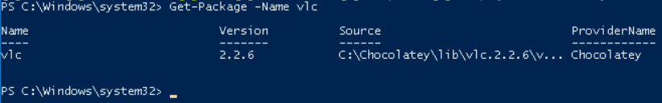

Click Check my progress to verify the objective.

VLC

Check my progress

**Uninstalling GIMP**

You can also use Chocolatey to uninstall programs, too. If you've closed your Powershell window, reopen it again by searching for it in the Start Menu, then right-clicking it and selecting "Run as Administrator".

You can use uninstall GIMP, a photo editor, using this command:

Choco Uninstall GIMP

You'll be prompted to confirm your choice again by typing "Y" (for "Yes"). Once the process finishes, GIMP will no longer be installed on your system. You can verify this with the following command and seeing that GIMP is not listed:

Get-Package

Click Check my progress to verify the objective.

GIMP

Check my progress

**Conclusion**

Congrats! You've successfully installed and uninstalled programs on Windows using both the GUI and CLI tools, as well as archived and unarchived .tar files.